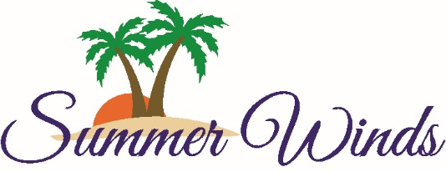
Homeowner’s Association
1505 Salter Path Road
Atlantic Beach, NC 28512
252-247-2080 / summerwindscondos.com

Dear Homeowner:

Pursuant to Article 14 of the Declaration of Unit Ownership and By-Laws of Summer Winds Condominiums, Inc., the Board of Directors advises you of the following:

- Your Monthly Assessment for the 2019-2020 Fiscal Year Annual Budget for the normal operation, management and maintenance of Summer Winds Condominiums shall be in the same amount for your unit as it was for the past fiscal year of 2018-2019; and
- The Special Assessment for the Elevator Modification Project for 2019-2021 shall be in the same amount for 24 months ending August 2021.

The Payment of the Monthly Assessment (Commonly called “Monthly Dues”) is due each month.

The Payment of the Special Assessment was due and payable September 1, 2019 in a lump sum or in twenty-four equal monthly installments due commencing September 1, 2019 and continuing on the 1st of each month thereafter with the final installment due August 1, 2021. Any payment amount in default will be subject to a late fee and bear interest at the highest rate permitted by law.

If you have any questions about your assessments, please call the Homeowners Association at 252-247-2080.

The Board of Directors would like you to know that it has not been easy to assess for capital improvements that have had to be addressed. We thank you for your patience and understanding and join you in looking forward to the completion of the elevator modification in April 2020.

Don’t forget the Annual Meeting on October 26, 2019 in the Hurricane Café at 10:00 AM. There will be a pool-side reception immediately following the meeting. If you cannot attend, please send in your Proxy or give it to someone you know so that we will have a quorum!!

Sincerely,

Your Board of Directors
Summer Winds Condominiums, Inc.

